Chemistry ATAR Year 12
Unit 3

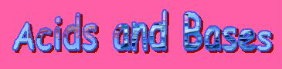

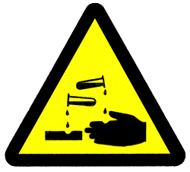

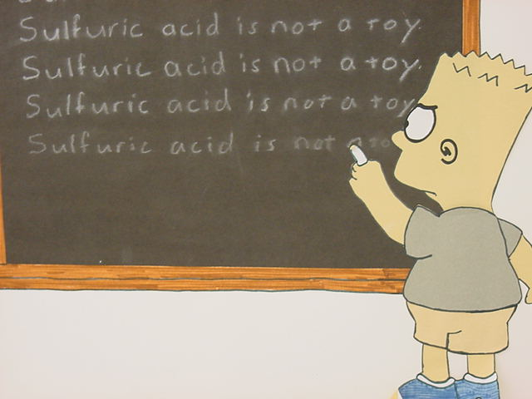

Acid-Base Reactions Review

Reactions of acids with metal oxides and hydroxides (bases)

- A metal hydroxide creates OH⁻ ions in solution.
  - NaOH Na⁺ + OH⁻
- A metal oxide is considered basic because it reacts with water to release OH⁻ ions.
  - MgO + H₂O Mg(OH)₂ Mg²⁺ + 2OH⁻

- These reactions are generally referred to as ____________________________ reactions.
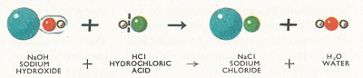
- The general equations for these two are:
- ____________________________
- ____________________________

- Examples of molecular or overall equations are:

HCl_{(aq)} + KOH_{(aq)} → KCl_{(aq)} + H₂O_{(l)}
2HNO_{3(aq)} + Ca(OH)_{2(aq)} → Ca(NO₃)_{2(aq)} + 2H₂O_{(l)}

- (Note: the hydronium ion, H₃O⁺_{(aq)}, can be represented as H⁺_{(aq)})

- Write down the ionic equation for these two reactions:
________________________________________________________
________________________________________________________
- The hydroxides of group 13 metals and transition metals are generally sparingly soluble, so the ionic equations include the formula of the solid metal hydroxide.
- For example the ionic equation for hydrochloric acid with solid iron(III)hydroxide is:

________________________________________ (The spectator ion will be __________ )

- Reactions between acids and metal oxides generally involve the metal oxide in a solid state.
- Give the overall equation and the ionic equation for the next examples:

Nitric acid with magnesium oxide:
Overall: _______________________________________________________
Ionic: _______________________________________________________

Sulfuric acid with solid sodium oxide:
Overall: _______________________________________________________
Ionic: _______________________________________________________

Reactions of acids with carbonates and hydrogencarbonates

- The general equations for these two are:
- ________________________________________________________

________________________________________________________

- Group 1 metal carbonates and all hydrogen carbonates are soluble in water and carbonates of all the other metals are insoluble in water so their formulae are written as solids.
- Write the ionic equation of the following:
Reaction of hydrochloric acid with aluminium carbonate
________________________________________________________
Reaction of nitric acid with solid potassium hydrogencarbonate
________________________________________________________
- Many antacids have metal hydroxides, carbonates and hydrogen carbonates as the active ingredient.
Reactions of acids with reactive metals (K, Na, Ca, Mg, Zn, Al and Fe)

- The general equation for this reaction is:

acid + reactive metal → ____________________________

- Examples are: (complete the ionic equation)
Hydrochloric acid with magnesium
________________________________________________________

Reactions of acids with sulphides (S²⁻) and sulfites (SO₃²⁻)

- The general equations for these two are:
  - acid + sulfide → salt solution + hydrogen sulphide gas (H₂S – colourless, pungent)
                - rotten egg gas
  - acid + sulfite → salt solution + sulfur dioxide gas + water (SO₂ – colourless, pungent)

- Examples are: (complete the ionic equation)
Nitric acid with a solution of sodium sulphide
________________________________________________________
Hydrochloric acid with solid magnesium sulfite
________________________________________________________

- If a weak acid is involved, it will be represented in the ionic equation in their “un-ionised” form eg. acetic acid will be CH₃COOH(aq).

Reactions of base with an amphoteric oxide or hydroxide

- The Bayer Process separates aluminium oxide from the bauxite. Aluminium oxide and hydroxide are both examples of amphoteric compounds.
- An amphoteric substance is able to act as both an acid and a base.
- As well as reacting with acids, aluminium oxide and aluminium hydroxide react with a base such as sodium hydroxide to produce the aluminate ion, a complex ion:
- As an acid:
Al₂O₃(s) + 2OH⁻(aq) + 3H₂O(l) → 2[Al(OH)₄]⁻(aq)
Al(OH)₃(s) + OH⁻(aq) → [Al(OH)₄]⁻(aq)
aluminate ion
- As a base:
Al₂O₃ + 6H⁺ 2Al³⁺ + 3H₂O

- Problem Set
• zinc and hydrochloric acid
________________________________________________________
• solid calcium carbonate and hydrochloric acid
________________________________________________________
• solid potassium oxide and sulfuric acid
________________________________________________________
• barium hydroxide solution and nitric acid
________________________________________________________

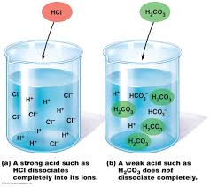
What are acids and bases?

Electrolytes

- Substances which dissolve to form ions in solution are called electrolytes.

- All ionic compounds and the strong acids are strong electrolytes. These dissolve in water producing independent mobile ions.
  - HCl H⁺ + Cl⁻ (ionisation)
  - NaCl Na⁺ + Cl⁻ (dissociation)


- Weak electrolytes only produce a few ions in solution with most of the substance existing in solution as molecules.
  - CH₃COOH ⇋ H⁺ + CH₃COO⁻

- Water is a covalent molecule that is a very weak electrolyte. The self ionisation of water is: H₂O_{(l)} + H₂O_{(l)} ⇋ H₃O⁺_{(aq)} + OH⁻_{(aq)}
- In ionisation of water, equilibrium strongly favours reactants so only small concentration of H⁺_{(aq)} and OH⁻_{(aq)} ions formed and most of water remains as unionised water molecules.
- The value of the equilibrium constant for this reaction is 1 x 10⁻¹⁴ which is a very small value.
- This shows that the concentration of ions in pure water is very small.

- Describe the following as soluble, insoluble, strong electrolyte, weak electrolyte or non-electrolyte. Explain each situation.

NaCl_{(aq)} ________________________________________________________

CH₃COOH_{(aq)} ________________________________________________________

CH₃CH₂OH_{(l)} ________________________________________________________
(ethanol)

- Order the above in terms of their conductivity (high to low).

________________________________________________________

  - All ionic substances dissociate in water when they dissolve. For substance with low solubility, the small portion that does dissolve is fully dissociated.

  - NOTE: dissociation is a process where pre-existing ions in a substance separate.
- e.g. an ionic solid dissolving
- MgBr₂ Mg²⁺ + 2Br⁻ is dissociation.

- Write dissociation equations for the following.

NaCl_{(s)} ________________________________________________________

(NH₄)₂SO_{4(s)} ________________________________________________________

  - Ionisation is a process of actually forming ions that weren’t initially present.
- e.g. a covalent molecule dissolving and forming ions.
- HCl H⁺ + Cl⁻ is ionisation.

- Some covalent molecular compounds are able to either partially or fully ionise in aqueous solutions.

- Write ionisation reactions for the following.

H₂SO_{4(aq)} ________________________________________________________

CH₃COOH_{(aq)} ⇋ ________________________________________________________

- The concentration of each ion in a solution of strong electrolyte is the concentration of the electrolyte multiplied by that ion’s subscript in the electrolytes formula.

- Write ionic equations for the precipitation of:
- Al(OH)₃ from a mixture of AlCl_{3(aq)} and NaOH_{(aq)} solutions.
________________________________________________________

- Ca₃(PO₄)₂ from a mixture of CaCl_{2(aq)} and K₃PO_{4(aq)} solutions.
________________________________________________________

Properties of Acids and Bases

ACIDS

- Acids can from when substances like hydrogen chloride gas dissolve in water.
HCl_{(g)} + H₂O_{(l)} H₃O⁺_{(aq)} + Cl⁻_{(aq)}

- Acids can be solutions of non-metal oxides such as SO₃ an NO₂.
SO_{3(g)} + H₂O_{(l)} H₂SO_{4(aq)}
NO_{2(g)} + H₂O_{(l)} HNO_{3(aq)}

- Acids have the following properties.
- react with reactive metals to produce hydrogen gas.
acid + reactive metal hydrogen + salt

2HCl_{(aq)} + Mg_{(s)} H_{2(g)} + MgCl_{2(aq)} MOLECULAR EQUATION
or
2H⁺_{(aq)} + Mg_{(s)} H_{2(g)} + Mg²⁺_{(aq)} IONIC EQUATION
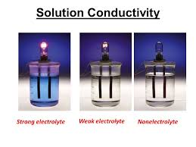
(a salt is the compound formed when one or more of the acidic hydrogen atoms from an acid has been replaced by a metal ion.
HCl NaCl, KCl, AlCl₃
HNO₃ NaNO₃, Fe(NO₃)₃
H₂SO₄ KHSO₄, BaSO₄

- conduct electricity
- affect indicators e.g. turn blue litmus red
- taste sour
- react with carbonates or hydrogen carbonates to produce carbon dioxide, salt and water
acid + carbonate carbon dioxide + salt + water

2H⁺_{(aq)} + Na₂CO_{3(s)} CO_{2(g)} + 2Na⁺_{(aq)} + H₂O_{(l)}

acid + hydrogen carbonate carbon dioxide + salt + water

H⁺_{(aq)} + HCO₃⁻_{(aq)} CO_{2(g)} + H₂O_{(l)}
- react with metal oxides or metal hydroxides to produce salt and water
acid + metal oxide salt + water

2H⁺_{(aq)} + CuO_{(s)} Cu²⁺_{(aq)} + H₂O_{(l)}

acid + metal hydroxide salt + water

H⁺_{(aq)} + OH⁻_{(aq)} H₂O_{(l)}

BASES

- Bases are generally compounds of metal oxides or metal hydroxides (except ammonia which accepts H⁺ ions to form ammonium ions).

- Bases have the following properties
- conduct electricity
- affect indicators e.g. turn red litmus blue
- taste bitter
- soapy feel
- react with acids to from salt and water
acid + base salt + water

2HCl_{(aq)} + Ca(OH)_{2(aq)} CaCl_{2(aq)} + 2H₂O_{(l)}
or
H⁺_{(aq)} + OH⁻_{(aq)} H₂O_{(l)}
- An amphoteric substance can act as an acid or a base
- e.g. amphoteric oxides Al₂O₃ and ZnO
- Al₂O_{3(s)} + 6H⁺_{(aq)} 2Al³⁺_{(aq)} + 3H₂O_{(l)}
- ZnO_{(s)} + 2OH⁻_{(aq)} + H₂O_{(l)} Zn(OH)₄²⁻_{(aq)}
- amphoteric substances include metal such as Al, Cr, Zn

- bases react with amphoteric metals to produce hydrogen gas
base + amphoteric metal + water complex ion + hydrogen

2OH⁻_{(aq)} + 2Al_{(s)} + 6H₂O_{(l)} 2[Al(OH)₄]²⁻_{(aq)} + 3H_{2(g)}

- bases dissolve amphoteric metal hydroxides to form complex ions
base + amphoteric metal hydroxide complex ion

2OH⁻_{(aq)} + Zn(OH)_{2(s)} [Zn(OH)₄]²⁻_{(aq)}

base + amphoteric metal oxide + water complex ion

2OH⁻_{(aq)} + Al₂O_{3(s)} + H₂O_{(l)} 2[Al(OH)₄]⁻_{(aq)}

- Define the following terms:
electrolyte
________________________________________________________________________

dilute
________________________________________________________________________
________________________________________________________________________
concentrated
________________________________________________________________________
________________________________________________________________________
neutralisation
________________________________________________________________________

strong acid
________________________________________________________________________

weak acid
________________________________________________________________________

strong base
________________________________________________________________________

weak base
________________________________________________________________________

pH
________________________________________________________________________

________________________________________________________________________

⇋
________________________________________________________________________

Models and theories are contested and refined or replaced when new evidence challenges them, or when a new model or theory has greater explanatory scope.

Theories of Acids and Bases

- In general, acids and bases are substances which dissolve in water and alter the natural [H⁺] and [OH⁻] of water.
- Several famous scientists proposed ideas about acids – these have been refined.
  - Antoine Lavoisier worked with oxides and suggested all acids contain oxygen.
  - Humphrey Davey suggested the presence of hydrogen makes something acidic.
- couldn’t explain substances like CH₄.
  - Justin Von Liebig extended this idea to acids having replaceable hydrogen.
- could explain production of H₂ but not NO₂ with conc. nitric acid.

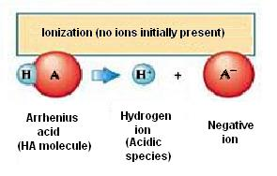
Arrhenius Theory

- Svante Arrhenius defined acids as ‘substances that produced hydrogen ions in solution and bases as substances that contained hydroxyl ions in solution’.

- Acids dissolve in water to form H⁺ ions in solution (ionisation).
- Hydrochloric acid is strong acid that creates a high proportion of H⁺ in solution.
  - Strong acid = complete ionisation.

HCl_{(g)} H⁺_{(aq)} + Cl⁻_{(aq)}

- Ethanoic acid is a weak acid and only produces a small proportion H⁺.
  - Weak acid = partial ionisation.

CH₃COOH_{(l)} ⇋ CH₃COO⁻_{(aq)} + H⁺_{(aq)}

- Substances that produce H⁺_{(aq)} when dissolved in water include:
- molecular acids like HNO₃, H₂SO₄, CH₃COOH.
- various ions like NH₄⁺, HSO₄⁻.
- NH₄⁺ + H₂O ⇋ H₃O⁺ + NH₃
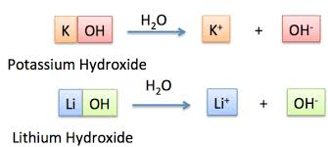
- Bases dissociate to form OH⁻ ions in solution.
- Potassium hydroxide is a strong bases that creates a high proportion of OH⁻ ions in solution.
  - Strong base = complete ionisation

KOH_{(aq)} K⁺_{(aq)} + OH⁻_{(aq)}

- As with acids there are some bases in which only create a small proportion of the base species react with water to form hydroxide ions.
  - Weak base = partial ionisation

- Arrhenius also proposed the neutralisation reaction:
  - Acid + base salt + water
  - HCl + NaOH NaCl + H₂O
  - H⁺ + OH⁻ H₂O

Limitations to the Arrhenius Theory

- A limitation of the theory is that in order for a substance to release either H⁺ or OH⁻ ions, it must contain that particular ion.
- This theory cannot explain why ammonia (NH₃) is considered a weak base.
  - In the presence of water, NH₃ releases hydroxide ions into solution, but does not contain OH⁻ itself.
    - NH₃ + H₂O ⇋ NH₄⁺ + OH⁻ (NOTE: NH₄OH does not exist on its own)
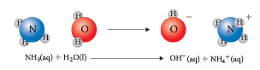
  - Ammonia reacts with HCl to form ammonium chloride. There is no water produced and no OH⁻ ions involved.
    - NH₃ + HCl NH₄Cl

- Another limitation of the theory is it cannot explain why non-metal oxides, such as CO₂, NO₂ and SO₃ can have acidic properties.
  - In the presence of water, NO2 releases hydrogen ions into solution, but does not contain H⁺ itself.
    - NO₂ + H₂O HNO₃ H⁺ + NO₃⁻

Acids are substances that can act as proton (hydrogen ion) donors and can be classified as monoprotic or polyprotic, depending on the number of protons available for donation.

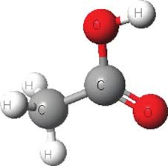
Monoprotic and Multiprotic acids
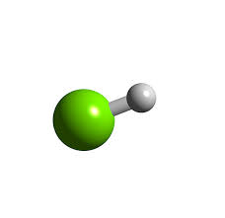
- Monoprotic acids – have one hydrogen atom per molecule which can be ionised in an aqueous solution. Examples: HCl, HNO₃ and CH₃COOH.

HCl_{(g)} + H⁺_{(aq)} + Cl⁻_{(aq)}

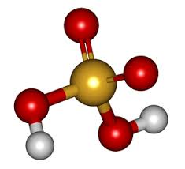
  - Note: although CH₃COOH has 4 H’s, only one is ionisable.

- Diprotic acids – have two ionisable hydrogen atoms per molecule of acid.
H₂SO_{4(l)} H⁺_{(aq)} + HSO₄⁻_{(aq)}
HSO₄⁻_{(aq)} ⇋ H⁺_{(aq)} + SO₄⁻²_{(aq)}

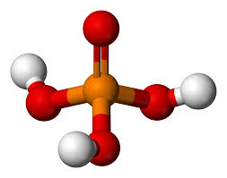
- Triprotic acids - three ionisable hydrogen atoms per molecule of acid.
H₃PO_{4(aq)} + H₂O_{(l)} ⇋ H₃O⁺_{(aq)} + H₂PO₄⁻_{(aq)}
H₂PO₄⁻_{(aq)} + H₂O_{(l)} ⇋ H₃O⁺_{(aq)} + HPO₄⁻²_{(aq)}
HPO₄²⁻_{(aq)} + H₂O_{(l)} ⇋ H₃O⁺_{(aq)} + PO₄⁻³_{(aq)}

- Note: the number of H’s available gives no indication about the strength of the acid.
- Note: in the above reactions, the reverse process is much more favoured.

- Some bases also provide more than one hydroxide ion when they dissociate in water.
NaOH_{(s)} Na⁺_{(aq)} + OH⁻_{(aq)} = one OH⁻ Ca(OH)_{2(s)} Ca²⁺_{(aq)} + 2OH⁻_{(aq)} = two OH⁻

- Problem Set

1. How many moles of hydroxide ions would react with one mole of the following?
a. HNO₃ d. H₂SO₄
- H₃PO₄ e. HF
- CH₃COOH f. HCOOH
2. How many moles of hydrogen ions would react with one mole of the following bases?
a. NaOH b. Fe(OH)₃
c. Ca(OH)₂
3. Write equations for the successive ionisation of oxalic acid (H₂C₂O_{4 (aq)} )
__________________________________________________________________________
The strength of acids is explained by the degree of ionisation at equilibrium in aqueous solution, which can be represented by chemical equations and acidity constants (K_{a}).

__________________________________________________________________________
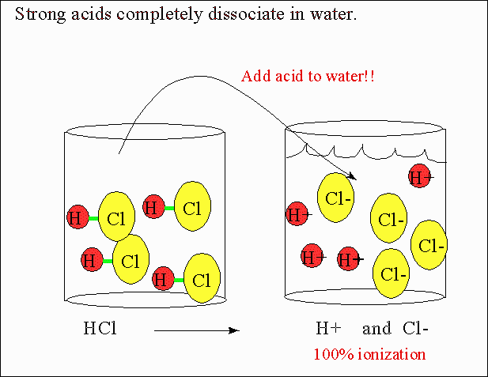
- The strength of an acid refers to how easily the molecule produces ions in solution.
  - Strong acid like HCl, H₂SO₄ and HNO₃ are fully ionised in solution.
- HCl is strong because it is essentially completely ionised in aqueous solution.
- In theory, very few HCl molecules will be left in solution.

HCl_{(g)} H⁺_{(aq)} + Cl⁻_{(aq)}

  - Because equilibrium strongly favours formation of products, a single arrow showing only the forward reaction is used in the equation.

H₂SO_{4(aq)} H⁺_{(aq)} + HSO₄⁻_{(aq)}

  - Note: H₂SO₄ fully ionises to HSO₄⁻ and H⁺,
  - then HSO₄⁻ partially ionises to SO₄²⁻ and H⁺.

  - Weak acids like H₃PO₄, CH₃COOH and HSO₄⁻ are only partially ionised in solution.
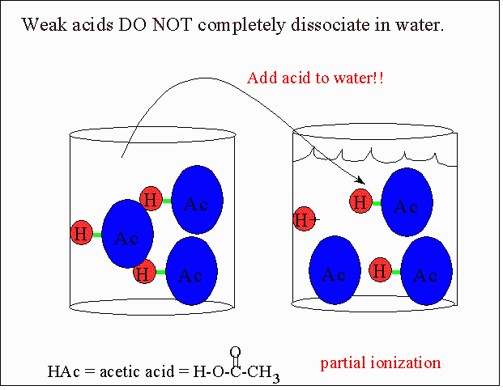
CH₃COOH_{(l)} ⇋ CH₃COO⁻_{(aq)} + H⁺_{(aq)}
HSO₄⁻_{(aq)} ⇋ H⁺_{(aq)} + SO₄²⁻_{(aq)}

- Double arrows indicate that equilibrium exists between unionised molecules of ethanoic acid and the ions in solution.
- For example, in a 0.10 mol L⁻¹ ethanoic acid solution only about 1% of ethanoic acid molecules are ionised, equilibrium strongly favours reactants.
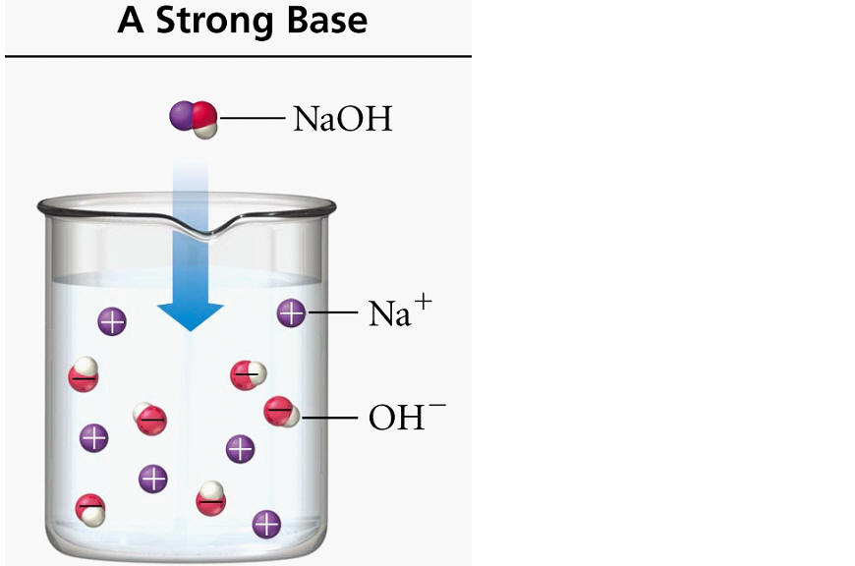

- Strong bases like NaOH, KOH and Ca(OH)₂ easily dissociate into ions.

NaOH_{(aq)} Na⁺_{(aq)} + OH⁻_{(aq)}

- Weak bases like Na₂CO₃ and NH₃ create equilibria that only release small portions of OH⁻.

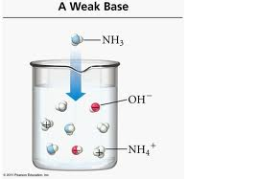
NH_{3(g)} + H₂O_{(l)} ⇋ NH₄⁺_{(aq)} + OH⁻_{(aq)}

- Although NH₃ contains no hydroxide ions of its own, it produces hydroxide ions by reacting with water.
- Again, equilibrium between unionised NH₃ molecules and NH₄⁺ and OH⁻ ions strongly favours the reactants and only a small proportion of the ions is present.

- The concentration of an acid or base solution refers to relative amounts of solute in a solvent.
- It is generally expressed as the number of moles of solute per litre of solution.
e.g. 0.5 mol L⁻¹ CH₃COOH is a dilute solution of a weak acid.
5 mol L⁻¹ CH₃COOH is concentrated solution of a weak acid.
0.1 mol L⁻¹ HCl is a dilute solution of a strong acid.
10 mol L⁻¹ HCl is a concentrated solution of a strong acid.
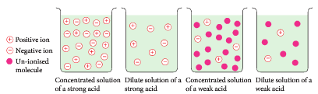

- For the same molarity, a strong acid always produces a higher H⁺_{(aq)} concentration, than a weak acid.

Strengths of Acids and Bases

Ionisation of Common Acids Listed in Order of Decreasing Strength

Acid Strength | Acid Name | Ionisation Equation | Major Species Present in Solution
strong | HCl hydrochloric acid | HCl _{(aq)} → H⁺ _{(aq)} + Cl⁻ _{(aq)} | almost entirely H⁺ _{(aq)} and Cl⁻ _{(aq)} negligible HCl _{(aq)}.
 | H₂SO₄ sulphuric acid | H₂SO₄ _{(aq)} → H⁺ _{(aq)} + HSO₄⁻ _{(aq)} | almost entirely H⁺ _{(aq)} and HSO₄⁻ _{(aq)}, some SO₄⁻² _{(aq)}, negligible H₂SO₄ _{(aq)}.
 | HNO₃ nitric acid | HNO₃ _{(aq)} → H⁺ _{(aq)} + NO₃⁻ _{(aq)} | almost entirely H⁺ _{(aq)} and NO₃⁻ _{(aq)}, negligible HNO₃ _{(aq)}.
 | H₂C₂O₄ oxalic acid | H₂C₂O₄ _{(aq)} H⁺ _{(aq)} + HC₂O₄⁻ _{(aq)} | mostly H₂C₂O₄ _{(aq)}, moderate concentrations of H⁺ _{(aq)} and HC₂O₄⁻ _{(aq)}.
 | H₂SO₃ sulphurous acid | H₂SO₃ _{(aq)} H⁺ _{(aq)} + HSO₃⁻ _{(aq)} | mostly H₂SO₃ _{(aq)}, moderate concentrations of H⁺ _{(aq)} and HSO₃⁻ _{(aq)}.
moderate | HSO₄⁻ hydrogensulfate | HSO₄⁻ _{(aq)} H⁺ _{(aq)} + SO₄⁻² _{(aq)} | mostly HSO₄⁻ _{(aq)}, moderate concentrations of H⁺ _{(aq)} and SO₄⁻² _{(aq)}.
 | H₃PO₄ phosphoric acid | H₃PO₄ _{(aq)}  H⁺ _{(aq)} + H₂PO₄⁻ _{(aq)} | mostly H₃PO₄ _{(aq)}, low H⁺ _{(aq)} and H₂PO₄⁻ _{(aq)}, very low HPO₄²⁻ _{(aq)}.
 | CH₃COOH ethanoic acid | CH₃COOH _{(aq)} H⁺ _{(aq)} + CH₃COO⁻ _{(aq)} | almost entirely CH₃COOH _{(aq)}, low H⁺ _{(aq)} and CH₃COO⁻ _{(aq)}.
 | H₂PO₄⁻ dihydrogen- phosphate ion | H₂PO₄⁻ _{(aq)}  H⁺ _{(aq)} + HPO₄⁻² _{(aq)} | almost entirely H₂PO₄⁻ _{(aq)}, low concentrations of H⁺ _{(aq)} and HPO₄⁻² _{(aq)}.
 | H₂S hydrogen sulfide | H₂S _{(aq)}   H⁺ _{(aq)} + HS⁻ _{(aq)} | almost entirely H₂S _{(aq)}, very low concentrations of H⁺ _{(aq)} and HS⁻ _{(aq)}.
weak | NH₄⁺ ammonium ion | NH₄⁺ _{(aq)} H⁺ _{(aq)} + NH₃ _{(aq)} | almost entirely NH₄⁺ _{(aq)}, very low concentrations of H⁺ _{(aq)} and NH₃ _{(aq)}.

Acidity constant K_{a}

- The degree of ionisation of an acid can be related to its equilibrium constant.
- Consider the ionisation of a weak acid, HF.
HF_{(g)}+ H₂O_{(l)} H₃O⁺_{(aq)} + F⁻_{(aq)}

- The acid dissociation equilibrium constant, K_{a}, expression for this reaction is:
$$K_{a}= \frac{\left[H_{3}O^{+}\right][F^{-}]}{\left[HF\right]}$$
- K_{a} for this reaction is 7.6 x 10⁻⁴.
- This very small value indicates that very few ions will be created in solution. Since a very small proportion of H⁺ is produced, HF is a weak acid.
- HCl is a very strong acid with a K_{a} value of 1.3 x 10⁶. This indicates that the forward reaction is very much favoured and HCl ionises to a very large extent.
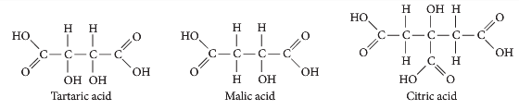
Common acids in wine.

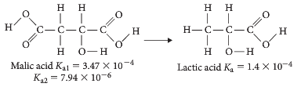

K_{a} values for weak acids.

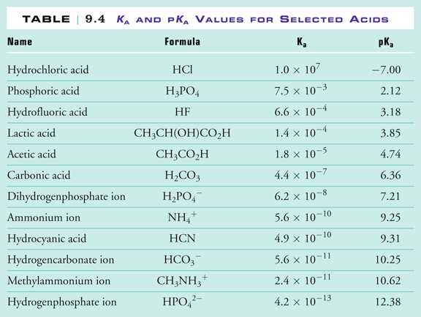

Sulfuric acid – H₂SO₄ K_{a} = 1.0 x 10³, Hydrogen sulfate ion – HSO₄⁻ K_{a} = 1.0 x 10⁻²
Carbonic acid – H₂CO₃ K_{a} = 4.4 x 10⁻⁷, Hydrogen carbonate ion – HCO₃⁻ K_{a} = 4.7 x 10⁻¹¹
Phosphoric acid – H₃PO₄ K_{a} = 7.1 x 10⁻³,
Dihydrogen phosphate ion – H₂PO₄⁻ K_{a} = 6.3 x 10⁻⁸
Hydrogen phosphate ion – HPO₄²⁻ K_{a} = 4.2 x 10⁻¹³

The relationship between acids and bases in equilibrium systems can be explained using the Brønsted-Lowry model and represented using chemical equations that illustrate the transfer of protons between conjugate acid-base pairs.

Brønsted-Lowry Theory

- Johannes Brønsted and Thomas Lowry realised that the Arrhenius model was incomplete as it could not explain acids that were not in solutions, acid salts like NH₄Cl, basic salts like Na₂CO₃ and the basic nature of NH₃.
- Independently, they formed a new theory of acids and bases.

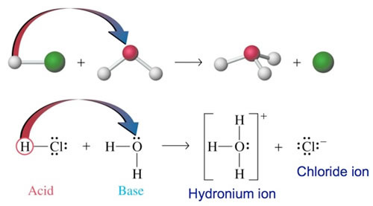
- Acids are proton donors that result in the formation of hydrogen ions (H⁺), or more correctly, a hydronium ion (H₃O⁺), in water.

e.g. hydrogen chloride in water to produce hydrochloric acid.
HCl_{(g)} + H₂O_{(l)} H₃O⁺_{(aq)} + Cl⁻_{(aq)}
acid base
- HCl donates a proton to H₂O and acts as an acid, the H₂O accepts the proton and acts as a base.

- Note: the H⁺ ion does not exist for very long in water. As soon as meets a water molecule, they combine to create H₃O⁺. However, H⁺ and H₃O⁺ are interchangeable.

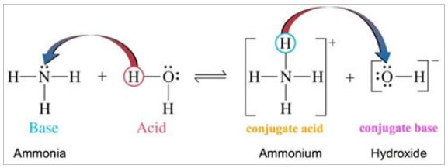
- Bases are proton acceptors that result in the formation of hydroxide ions (OH⁻) in water.
e.g. ammonia in water to produce ions.
NH_{3(aq)} + H₂O_{(l)} ⇋ NH₄⁺_{(aq)} + OH⁻ _{(aq)}
base acid
- NH₃ accepts a proton and is acting as a base; H₂O donates a proton to NH₃ as acts as an acid.

- In a reaction, the substance losing or donating a H⁺ ion (called a proton) is an acid.
- The substance gaining or accepting the proton (H⁺ ion) is a base.
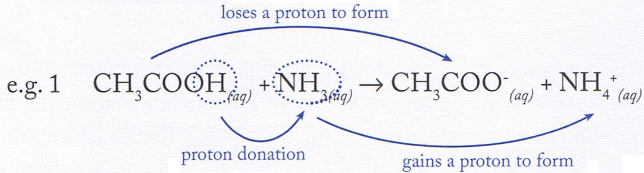

- CH₃COOH is acting as an acid, NH₃ as a base.

- Strong acids have a strong tendency to lose a proton, strong bases have a tendency to gain a proton.

- Amphiprotic substances are substances that are able to donate or accept a proton, depending on the substance that they are reacting with.
- For example, hydrogen carbonate ion (HCO₃⁻)
  - When placed in an acidic environment, HCO₃⁻ can act as a proton acceptor.
HCO₃_ + H⁺ ⇋ H₂CO₃
  - When placed in a basic environment, HCO₃⁻ can act as a proton donor.
HCO₃_ + OH⁻ ⇋ CO₃²⁻ + H₂O

- An amphoteric substance is able to react both as a base and as an acid.

Conjugate acids and bases

- In an acid-base reaction, conjugate pairs can be produced.
- The product species that accepts the proton has the ability to re-donate it.
- It is called a conjugate acid.
- The species that lost the proton can accept another one and is known as a conjugate base.
- An acid that has donated a proton is a potential base.
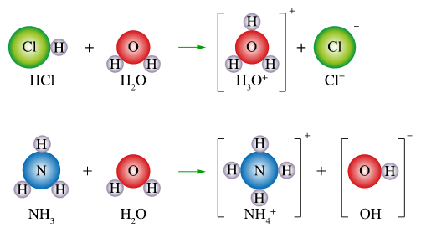

HCl_{(g)} + H₂O_{(l)} H₃O⁺_{(aq)} + Cl⁻_{(aq)}
acid base conjugate conjugate
acid base

Water is said to be amphiprotic – it can accept or donate a proton

H₂C₂O_{4(aq)} + H₂O_{(l)} ⇋ H₃O⁺_{(aq)} + HC₂O₄⁻_{(aq)}
acid base conjugate conjugate
acid base

- More examples

e.g. ammonia in water to produce ammonium hydroxide solution

NH_{3(g)} + H₂O_{(l)} ⇋ NH₄⁺_{(aq)} + OH⁻_{(aq)}
base acid conjugate conjugate
acid base

CO₃²⁻_{(aq)} + H₂O_{(l)} ⇋ HCO₃⁻_{(aq)} + OH⁻_{(aq)}
base acid conjugate conjugate
acid base

- Generally, the stronger the acid the weaker the conjugate base.
  - A conjugate acid is simply the base species with one proton added.
  - The conjugate base is the acid species with one proton removed.

Acid-Base Neutralisation Reactions

- In an acid base reaction, the acidic and basic properties of the reactants are nullified, hence the name NEUTRALISATION.

- Strong acid / strong base
H⁺_{(aq)} + OH⁻_{(aq)} H₂O_{(l)}

- Weak acid / strong base
CH₃COOH_{(aq)} + OH⁻_{(aq)} CH₃COO⁻_{(aq)} + H₂O_{(l)}

- Strong acid / weak base
H⁺_{(aq)} + NH_{3(aq)} NH₄⁺_{(aq)}

- Weak acid / weak base
CH₃COOH_{(aq)} + NH_{3(aq)} ⇋ CH₃COO⁻_{(aq) +} NH₄⁺_{(aq)}

- The reaction between a metal oxide and an acid is also a neutralisation reaction.
- Problem Set Answers p 37

- The addition of ammonium chloride to water can be described by the following equation:

NH₄⁺_{(aq)} + H₂O_{(l)} ⇋ NH_{3(aq)} + H₃O⁺_{(aq)}

- Name an acid in this reaction. ____________________________________
- Use the appropriate theory to explain why the substance chosen is acting as an acid.
__________________________________________________________________________
- If applicable, identify the acid and the base in each of the following reactions:

  - HS⁻ (aq) + CO₃²⁻(aq) ⇋ S²⁻ (aq) + HCO₃⁻(aq)

  - HPO₄²⁻(aq) + H₂O(1) ⇋ H₂PO₄⁻(aq) + OH⁻(aq)

  - CH₃NH₂(aq) + CH₃COOH(aq) ⇋ CH₃NH₃⁺(aq) + CH₃COO⁻(aq)

  - 2H₂0(g) + Mg(s) → Mg(OH)₂ (s) + H₂ (g) ______________________
3. Identify the conjugate acids of Cl⁻, CO₃²⁻, NH₃, ClO₄, SO₃²⁻.
__________________________________________________________________________

4. Identify the conjugate bases of HF, HSO₄⁻, NH₄⁺, HPO₄²⁻, H₃O⁺.
__________________________________________________________________________

5. Write two equations for the hydrogen phosphate ion reacting with water as:
a. a base __________________________________________________
b. an acid. __________________________________________________
6. For the following reactions:
i. identify the conjugate acid-base pairs.
ii. Predict whether the reaction is likely to occur to a large extent or to only a small extent as written.
a. HCO₃⁻ _{(aq)} + F⁻ _{(aq)} CO₃²⁻ _{(aq)} + HF _{(aq)}
__________________________________________________________________________

__________________________________________________________________________
b. H₃O⁺ _{(aq)} + F⁻ _{(aq)} HF _{(aq)} + H₂O _{(l)}
__________________________________________________________________________

__________________________________________________________________________

SUMMARY

ACIDS
- substances that produce H⁺ or H₃O⁺ in aqueous solutions (i.e. proton donors).
- may be
- molecules HCl H⁺ + Cl⁻
HCl + H₂O H₃O⁺ + Cl⁻
- anions HSO₄⁻ ⇋ H⁺ + SO₄⁻
HSO₄⁻ + H₂O ⇋ H₃O⁺ + SO₄²⁻
- cations NH₄⁺ + H₂O ⇋ NH₃ + H₃O⁺

Salts like NH₄Cl and KHSO₄ are acidic in aqueous solution.

Acids are called strong acids if
- they completely ionise in solution
- equilibrium favours the products
- they readily form H⁺ ions

Examples include HCl, HNO₃, H₂SO₄
HNO₃ H⁺ + NO₃⁻
H₂SO₄ H⁺ + HSO₄⁻

Acids are called weak acids if
- they do not completely ionise (weak electrolytes)
- equilibrium favours a mixture of molecules and ions with many of the particles existing as molecules.

Examples include CH₃COOH, H₃PO₄, HF, H₂CO₃, NH₄⁺
CH₃COOH_{(aq)} + H₂O_{(l)} ⇋ H₃O⁺_{(aq)} + CH₃COO⁻_{(aq)}
H₂CO_{3(aq)} + H₂O_{(l)} ⇋ H₃O⁺_{(aq)} + HCO₃⁻_{(aq)}
NH₄⁺_{(aq)} + H₂O_{(l)} ⇋ H₃O⁺_{(aq)} + NH_{3(aq)}
BASES
- substances that produce OH⁻ in aqueous solutions (i.e. proton acceptors).
- may be
- ions NaOH Na⁺ + OH⁻
- molecules NH₃ + H₂O ⇋ NH₄ + OH⁻
- anions S²⁻ + H₂O ⇋ HS⁻ + OH⁻ proton
CO₃²⁻ + H₂O ⇋ HCO₃⁻ + OH⁻ acceptors

Salts like K₂S and Na₂CO₃ are basic in aqueous solution.

Bases are called strong bases if
- they completely dissociate in solution
- equilibrium favours the products
- they readily form OH⁻ ions

Examples include ionic hydroxides such as NaOH, KOH, Ca(OH)₂, Ba(OH)₂
KOH K⁺ + OH⁻

and metallic oxides
O²⁻ + H₂O 2OH⁻

e.g. CaO + H₂O Ca²⁺ + 2OH⁻

Bases are called weak bases if
- they do not completely dissociate (weak electrolytes)
- they react with water and release OH⁻ ions
- equilibrium favours a mixture of molecules and ions with many of the particles existing as molecules.

Examples include MgO, Na₂CO₃, NH₃

CO₃²⁻_{(aq)} + H₂O_{(l)} ⇋ OH⁻_{(aq)} + HCO₃⁻_{(aq)}
NH_{3(g)} + H₂O_{(l)} ⇋ OH⁻_{(aq)} + NH₄⁺_{(aq)}
- Write equations for the following when they dissolve in water.

NaHCO₃

MgO

Ba(OH)₂

H₂S

- What is an alkali?

The hydrolysis of salts of weak acids and weak bases can be represented using equations; the Brønsted-Lowry model can be applied to explain the acidic, basic and neutral nature of salts derived from bases and monoprotic and polyprotic acids

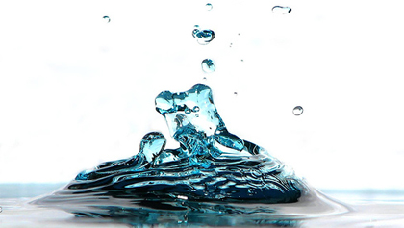
Hydrolysis

SALTS

- A salt is an ionic compound that contains a negative ion (an anion) other than the oxide ion, O²⁻ , or the hydroxide ion, OH⁻ .
- Examples are sodium fluoride, calcium carbonate, iron(III)sulphate, ammonium nitrate, sodium chloride etc.
- A salt can be thought of as a compound whose positive metal ion or NH₄⁺ (cation) comes from a base and the negative ion (anion) comes from an acid eg. for the salt sodium chloride , the sodium comes from the base NaOH and the chloride comes from the acid HCl.

- Name a possible acid and base where ammonium carbonate comes from?
_____________________________________________________________

Solutions of salts in water – hydrolysis of ions

- Neutralisation is the reaction between an acid and a base.

ACID + BASE SALT + WATER

- However, the resultant salt may not be neutral in aqueous solution due to the hydrolysis of water.

- In normal neutral water, [H⁺] = [OH⁻] = 1 x 10⁻⁷ M at 25⁰ C.
- When a salt dissolves in water it dissociates completely into ions. Salts are strong electrolytes.
- When salts dissolve in water, the ions may react with the water molecules to produce H⁺ or OH⁻. This is called HYDROLYSIS. It may affect the equilibrium.
e.g in a solution of sodium carbonate, the carbonate ion undergoes hydrolysis to
produce the hydrogencarbonate and hydroxide ion:
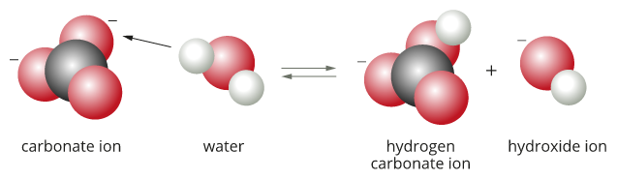

Na⁺ + H₂O NR

CO₃²⁻_{(aq)} + H₂O_{(l)} ⇋ HCO₃⁻_{(aq)} + OH⁻_{(aq)}

- The presence of the hydroxide ion, (OH⁻), causes this solution to be basic. The Na⁺ ion does not undergo hydrolysis.
- Depending on which ion, OH⁻ or H₃O⁺, are formed in any hydrolysis reaction determines whether the resulting solution will be basic, neutral or acidic.

- Another way to predict if a salt will acidic or basic is to look at the acid and base that react to create the salt.
  - Na₂CO₃ could be made from the following reaction.
  - NaOH + H₂CO₃ H₂O + Na₂CO₃
SB WA Basic salt

- Example: Explain why a solution of sodium ethanoate, NaCH₃COO, is slightly basic.
________________________________________________________________________
________________________________________________________________________
________________________________________________________________________
- ________________________________________________________________________

Acid-base properties of salt solutions

 | Neutral | Basic | Acidic
Anion | derived from strong acids  Cl⁻, NO₃⁻,  Br⁻, I⁻, SO₄²⁻ | derived from weak acids  F⁻, S²⁻, ClO⁻, CH₃COO⁻, CO₃²⁻, HCO₃⁻, PO₄³⁻, HPO₄²⁻ | derivred from polyprotic acids  HSO₄⁻,  H₂PO₄⁻
Cation | Dervived from strong bases  Li⁺, Mg²⁺,  Na⁺, Ca²⁺,  K⁺, Ba²⁺ | none | NH₄⁺  Al³⁺  Fe³⁺

- Hydrolysis and acidity of selected salts.

Salt | NaCl | Mg(HSO₄)₂ | KNO₃ | NH₄Cl | K₂CO₃ | Ca(HCO₃)₂ | Ba(OH)₂
Acidity | neutral |  |  |  |  | basic
Ion affecting acidity |  | HSO₄⁻ |  | NH₄⁺

- Predict the acidity of the following salts in solution (A, B or N).
NaNO₃ NaCH₃COO Na₂CO₃

General Rules

- Salts of strong acids – strong bases are neutral in aqueous solution.
e.g. KNO₃, NaCl, CaCl₂

KOH_{(s)} + HCl_{(aq)} KCl_{(aq)} + H₂O_{(l)}
salt neutral

Hydrolysis reaction: KCl_{(aq)} + H₂O_{(l)} K⁺_{(aq)} + Cl⁻_{(aq)} + H⁺_{(aq)} + OH⁻_{(aq)}
Salt

KCl_{(aq)} + H₂O_{(l)} K⁺_{(aq)} + Cl⁻_{(aq)} + H₂O_{(i)}
neutral

- Salts of strong bases – weak acids are basic in aqueous solutions.
e.g. Na₂CO₃, NaCH₃COO

3NaOH_{(aq)} + H₃PO_{4(aq)} Na₃PO_{4(aq)} + 3H₂O_{(l)}
salt

Hydrolysis reaction: Na₃PO_{4(aq)} + 3H₂O_{(l)} 3Na⁺_{(aq)} + PO₄³⁻_{(aq)} + 3H⁺_{(aq)} + 3OH⁻_{(aq)}
Salt

Na₃PO_{4(aq)} + 3H₂O_{(l)} 3Na⁺_{(aq)} + H₃PO_{4(aq)} + 3OH⁻_{(aq)}
Basic

- Salts of strong acids – weak bases are acidic in aqueous solutions.
e.g. NH₄Cl, NH₄NO₃

NH₄OH_{(aq)} + HCl_{(aq)} NH₄Cl_{(aq)} + H₂O_{(l)}
salt

Hydrolysis reaction: NH₄Cl_{(aq)} + H₂O_{(l)} NH₄⁺_{(aq)} + Cl⁻_{(aq)} + H⁺_{(aq)} + OH⁻_{(aq)}
Salt

NH₄Cl_{(aq)} + H₂O_{(l)} NH₄OH_{(aq)} + Cl⁻_{(aq)} + H⁺_{(aq)}
Acidic

- Salts of weak acids – weak bases may be slightly acidic, basic or neutral depending on the relative strengths of the acids and bases.
e.g NH₄CH₃COO is neutral – acidity due to NH₄⁺ is cancelled by basicity of CH₃COO⁻.

NH₄OH_{(aq)} + CH₃COOH_{(aq)} ⇋ NH₄CH₃COO_{(aq)} + H₂O_{(l)}
salt

Hydrolysis reaction: NH₄CH₃COO_{(aq)} + H₂O_{(l)} ⇋ NH₄⁺_{(aq)} + CH₃COO ⁻_{(aq)} + H⁺_{(aq)} + OH⁻_{(aq)}
salt
NH₄CH₃COO_{(aq)} + H₂O_{(l)} ⇋ NH₄OH_{(aq)} + CH₃COOH_{(aq)} + H₂O_{(l)}

  - Note: NH₄OH_{(aq)} and CH₃COOH_{(aq)} are both poor conductors due to low ions in solution.
  - However, putting them together to make NH₄CH₃COO_{(aq)} which is a soluble salt that conducts well.

- Amphiprotic salts can react with water to either donate or accept a proton.
- E.g. H₂PO₄⁻ could gain a proton to form H₃PO₄ or lose a proton to form HPO₄²⁻.
- Note: HPO₄²⁻ and PO₄³⁻ will readily accept protons.
  - Na₂HPO₄ and Na₃PO₄ in water both result in basic solutions.
- H₂PO₄⁻ is more likely to lose one.
  - NaH₂PO₄ in water results in an acidic solution

- What is the nature of the salt NH₄NO₃?
Predict – acidic (rule 3.)
Explain – NH₄⁺ reacts with water to releases H₃O⁺ ions which are acidic.
NH₄⁺_{(aq)} + H₂O_{(l)} ⇋ H₃O⁺_{(aq)} + NH_{3(aq)}
acidic

- Predict whether the following salts form acid, base or neutral solutions
  - MgCl₂ - ___________________________________________________
  - KHCO₃ - ___________________________________________________
  - NH₄Cl - ___________________________________________________

- Problem Set Answers p 36
1. Complete the following hydrolysis reactions and indicate the type of solution they form (acidic or basic).
• CO₃⁻² _{(aq)} + H₂O _{(l)} ___________________________________________________
• F⁻ _{(aq)} + H₂O _{(l)} ___________________________________________________
• HSO₄⁻ _{(aq)} + H₂O _{(l)} ___________________________________________________
• ClO⁻ _{(aq)} + H₂O _{(l)} ___________________________________________________
2. Predict the nature of each salt solution as being either acidic, basic or neutral:
• NH₄NO₃ ___________________ • NaCl ___________________
• Na₂CO₃ ___________________ • KH₂PO₄ ___________________
• MgF₂ ___________________ • K₂SO₄ ___________________
- Problem Set Answers p 36
1. If dissolved in water, some of the substances listed here will significantly alter the concentration of hydrogen ions and hydroxide ions [H⁺ _{(aq)}, OH⁻ _{(aq)}] normally present in water. If this does occur write a net ionic equation to show how this happens. Also indicated the effect on the H⁺ _{(aq)} and OH⁻ _{(aq)} concentrations, i.e. increased or decreased or no effect. Note: (a) is a gas, the rest are solids and form aqueous solutions. Some are weak electrolytes so need a double arrow. The first has been done to show you.

- HCl HCl_{(g)} + H₂O_{(l)} → H₃O⁺_{(aq)} + Cl⁻_{(aq)} H⁺↑ OH⁻↓
- NH₄Cl ___________________________________________________________
- LiCH₃COO ___________________________________________________________
- NaNO₃ ___________________________________________________________
- K₂O ___________________________________________________________
- NH₃ ___________________________________________________________
- Na₃PO₄ ___________________________________________________________
- CH₃COOH ___________________________________________________________
- H₂S ___________________________________________________________
- Na₂HPO₄ ___________________________________________________________
- MgBr₂ ___________________________________________________________
- NaHCO₃ ___________________________________________________________
- Ca(NO₃)₂ ___________________________________________________________
- H₃PO₄ ___________________________________________________________
- NaHSO₄ ___________________________________________________________
- K₂CO₃ ___________________________________________________________
2. A student used pieces of red and blue litmus paper to examine each of the following 1.0 mol L⁻¹ salt solutions. Describe and account for her observations, i.e. classify each solution as acidic, basic or neutral. Where the solution is not expected to be neutral, write the formula of the ion causing this.

- NaCl ___________________________________________________________
- KHCO₃ ___________________________________________________________
- SrCl₂ ___________________________________________________________
- Mg(HSO₄)₂ ___________________________________________________________
- KNO₃ ___________________________________________________________
- NH₄Cl ___________________________________________________________
- K₂HPO₄ ___________________________________________________________
- K₂S ___________________________________________________________
- NaCH₃COO ___________________________________________________________
- Mg(NO₃)₂ ___________________________________________________________
- Na₂CO₃ ___________________________________________________________
- CaBr₂ ___________________________________________________________

Water is a weak electrolyte; the self-ionisation of water is represented by K_{w} = [H⁺][OH⁻] where K_{w} = 1.0 x 10⁻¹⁴ at 25 ºC

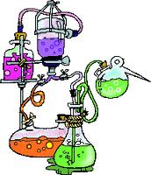
Ionisation of water and pH

Self-ionisation of Water

- Water is a weak acid and a weak base, therefore a weak electrolyte and ionises to form H⁺ and OH⁻.
H₂O_{(l)} + H₂O_{(l)} ⇋ H₃O⁺_{(aq)} + OH⁻_{(aq)}
OR
H₂O_{(l)} ⇋  H⁺_{(aq)} + OH⁻_{(aq)}
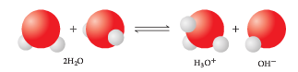
Disproportionation of water
- In this reaction, one water molecule behaves like an acid and the other as a base (amphoteric).
- This equation represents self-ionisation of water
- The equilibrium law expression is:
K_{w} = [H⁺][OH⁻]
[H₂O]
  - very few water molecules ionise.
  - liquids and solids are not included in the equation for the ionisation constant because their concentration is assumed to remain constant.
    - Thus K_{W} = [H⁺] [OH⁻] = 1 x 10⁻¹⁴ mol L⁻¹ at 25⁰ C.

Note: [ ] means concentration.

- In pure water at 298 K (25°C) the concentration of H⁺_{(aq)} and OH⁻_{(aq)} is equal.
[H⁺] = [OH⁻] = 1.0 x 10⁻⁷ mol L⁻¹

- If [H⁺] = [OH⁻] = 1 x 10⁻⁷ mol L⁻¹ solution is neutral.

- The [H⁺] [OH⁻] = 1x10⁻¹⁴ for any aqueous solution at 25⁰ C.

- For an acid in water: H⁺ forms, causing [H⁺] to be greater than [OH⁻].
  - [H⁺] > [OH⁻] therefore [H⁺] > 1 x 10⁻⁷ mol L⁻¹
- For a base in water: OH⁻ forms, causing [OH⁻] to be greater than [H⁺].
  - [OH⁻] > [H₃O⁺] therefore [OH⁻] > 1 x 10⁻⁷ mol L⁻¹
- The self-ionisation constant, K_{w}, for water is the equilibrium constant for a reaction that occurs in all aqueous solutions. Therefore [H⁺] [OH⁻] = K_{W} = 1 x 10⁻¹⁴ mol L⁻¹ at 25⁰ C.

K_{w} can be used to calculate the concentration of hydrogen ions or hydroxide ions in solutions of strong acids or bases.

- Worked Example
Calculate the concentrations of H⁺, Cl⁻ and OH⁻ in 1.0 x 10⁻² mol L⁻¹ HCl solution.
HCl_{(g)} H⁺_{(aq)} + Cl⁻_{(aq)}
[H⁺] = [Cl⁻] = 1.0 x 10⁻² mol L⁻¹
• Use K_{w} to calculate [OH⁻]
K_{w} = [H⁺] [OH⁻] = 1.0 x 10⁻¹⁴
= (1.0 x 10⁻²) [OH⁻] = 1.0 x 10⁻¹⁴
[OH-] = 1.0 x 10⁻¹⁴
1.0 x 10⁻²
= 1.0 x 10⁻¹² mol L⁻¹
- Worked Example
Calculate the concentrations of Na⁺, OH⁻ and H⁺ in a 4.0 x 10⁻³ mol L⁻¹ NaOH solution.
NaOH _{(s)} Na⁺ _{(aq)} + OH⁻ _{(aq)}

[Na⁺] = [OH⁻] = 4.0 x 10⁻³ mol L⁻¹

K_{w} = [H⁺] [OH⁻] = 1.0 x 10⁻¹⁴
= (4.0 x 10⁻³) [H⁺] = 1.0 x 10⁻¹⁴

[H⁺] = 1.0 x 10⁻¹⁴
4.0 x 10⁻³
= 2.5 x 10⁻¹² mol L⁻¹

- Problem Set ANSWERS p 39

1. A sample of water from a swimming pool has [OH⁻] = 1.6 x 10⁻⁷ mol L⁻¹.
- Calculate [H⁺]
- Is the swimming pool water acidic or basic?

2. Calculate the concentrations of the following:
- H⁺, NO₃⁻ and OH⁻ in 5.0 x 10⁻³ mol L-1 HNO₃.
- H⁺, Cl⁻ and OH⁻ in 1.5 mol L⁻¹ HCl.
- K⁺, OH⁻ and H⁺ in 0.25 mol L⁻¹ KOH
- Ba⁺², OH⁻ and H⁺ in 6.0 x 10⁻³ mol L⁻¹ Ba(OH)₂.

3. Determine the concentration of [H⁺] and [OH⁻] for each of the following solutions of strong acids and bases:

- 0.159 mol L⁻¹ HNO₃ _{(aq)}
- 1.0 x 10⁻³ mol L⁻¹ H₂SO₄ _{(aq)} [assume complete ionisation]
- 1.332 mol L⁻¹ KOH _{(aq)}
- 4.72 x 10⁻⁴ mol L⁻¹ Ca(OH)₂ _{(aq)}

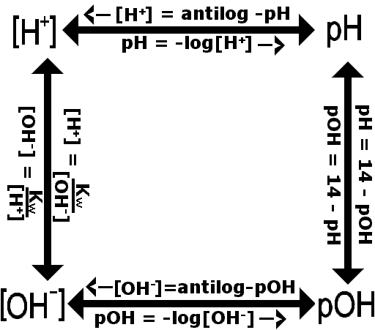
The pH scale is a logarithmic scale and the pH of a solution can be calculated from the concentration of hydrogen ions using the relationship pH = - log₁₀ [H⁺]

pH Scale

- This scale gives the acidity of a solution on a numerical scale. (No units).
- It is a measure of the level of [H⁺] in solution.
- pH of
  - acid less than 7 (0 – 6)
  - base greater than 7 (8 – 14)
  - neutral (such as distilled water) = 7
pH defined by: pH = -log₁₀[H⁺]

- Can be easily worked out as the negative of the index of the base 10.

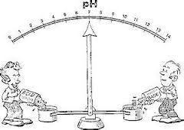
- Worked Example
Calculate the pH of a 1.0 x 10⁻³ mol L⁻¹ HCl solution. HCl _{(g)} H+ _{(aq)} + Cl- _{(aq)}
[H⁺] = 1.0 x 10⁻³ mol L⁻¹
pH = -log₁₀[H⁺]
pH = -log₁₀[1.0 x 10⁻³]
pH = 3.00

- Worked Example
Calculate the pH of a 2.0 x 10⁻² mol L⁻¹ NaOH solution. NaOH _{(s)} Na⁺ _{(aq)} + OH⁻ _{(aq)}
[OH⁺] = 2.0 x 10⁻² mol L⁻¹
• Calculate [H⁺]
[H⁺][OH⁻] = 1.0 x 10⁻¹⁴
[H⁺](2.0 x 10⁻²) = 1.0 x 10⁻¹⁴
[H⁺] = 1.0 x 10⁻¹⁴
2.0 x 10⁻²
[H⁺] = 5.0 x 10⁻¹³ mol L⁻¹
• Calculate the pH
pH = -log₁₀ [H⁺]
pH = -log₁₀ [5.0 x 10⁻¹³]
pH = 12.30
(or alternative calculate pOH, then find pH = 14 – pOH)

- Worked Example
Calculate the hydrogen ion and hydroxide ion concentration in a sample of milk with a pH of 6.40.
• Calculate [H⁺]
pH = -log₁₀[H⁺]
6.40 = -log₁₀[H⁺]
log₁₀[H⁺] = -6.40
[H⁺] = inverse log (-6.40)
[H⁺] = 3.98 x 10⁻⁷ mol L⁻¹
• Calculate [OH⁻]
[OH⁻] = 1.0 x 10⁻¹⁴
[H⁺]
[OH⁻] = 1.0 x 10⁻¹⁴
3.98 x 10⁻⁷
= 2.5 x 10⁻⁸ mol L⁻¹

- Determine the pH of a 0.155 mol L⁻¹ HNO_{3(aq)} solution.

- Calculate the pH of a 2.0 x 10⁻² M NaOH solution.

- Determine the concentration of H⁺_{(aq)} and OH⁻_{(aq)} ions in a sample of swimming pool water with pH of 6.2

Mixing a strong acid and strong base which are not in stoichiometric amounts

Steps involved:
  - Calculate the amount in moles of H⁺ in acid solution and the amount of moles of OH⁻ in base solution before the reaction occurs.
  - Assume the H⁺ and OH⁻ react in a 1:1 mole ratio, H⁺ + OH⁻ → H₂O, determine which is in excess.
  - Calculate the amount in moles of excess H⁺ or OH⁻.
  - Using the new volume of the mixed solution, calculate the concentration of excess H⁺ or OH.
  - Determine the pH of the solution from the concentration of H⁺ or OH⁻ from step 4.

- Example:

200 mL of a sodium hydroxide solution containing 5.00 g of sodium hydroxide is added to 200 mL of 0.300 mol L⁻¹ H₂SO₄. Calculate the pH of the solution resulting from this reaction.

Before mixing:
M(NaOH) $n= \frac{5.00}{39.998}$ n(H₂SO₄) = cV
= 39.998 g mol⁻¹ n = 0.125 mol NaOH = 0.30 x 0.200
= 0.06 mol

NaOH → Na⁺ + OH⁻ H₂SO₄ + 2H₂O → 2H₃O⁺ + SO₄²⁻
so moles of OH⁻ = 0.125 mol so moles H₃O⁺ = 2 x 0.06 = 0.120 mol

After mixing

OH⁻ + H₃O⁺ → 2H₂O
1 mol 1 mol 2 mol
have 0.125 mol 0.120 mol
need 0.120 mol 0.120 mol
excess 0.005 mol

so have 0.005 mol excess OH⁻ and total volume of solution is 0.200 + 0.200 = 0.400 L

$c\left(OH^{-}\right)= \frac{n}{V}= \frac{0.005}{0.4}$
= 1.25 x 10⁻² mol L⁻¹

K_{w} = [H₃O⁺] [OH⁻] = 1 x 10⁻¹⁴ pOH = -log[OH⁻]
[H₃O⁺] x 1.25 x 10⁻² = 1 x 10⁻¹⁴ = -log(1.25 x 10⁻²)
[H₃O⁺] = 1 x 10⁻¹⁴ / 1.25 x 10⁻² = 8 x 10⁻¹³ or = 1.9

pH = -log[H₃O⁺] = -log (8 x 10⁻¹³) pH = 14 – 1.9
= 12.1 = 12.1

- Problem Set Answers p 40

1. In the following pairs of solutions predict which solution would exhibit
• The highest [H⁺]
• The highest pH
• The greatest electrical conductivity

a. 0.1 mol L⁻¹ HCl and 0.1 mol L⁻¹ CH₃COOH
_____________________________________________________________________________
b. 0.1 mol L⁻¹ NaOH and 0.1 mol L⁻¹ NH₃
_____________________________________________________________________________
2. Give an example of each of the following:

• a concentrated solution of a strong acid. ______________________
• a dilute solution of a strong base. _________________________
• a concentrated solution of a weak acid. _________________________
3. Write equations for the ionisation or dissociation of the following:
• The strong acid HBr_{(g)}. __________________________________
• The weak acid H₂SO₃. __________________________________

4. Determine the final pH when the following pairs solutions are combined and the reaction is complete. Assume all solution volumes are additive.

a. 123 mL of 1.17 mol L⁻¹ NaOH _{(aq)} and 65.7 mL of 3.40 mol L⁻¹ HNO₃ _{(aq)}.

b. 375 mL of 0.152 mol L⁻¹ H₂SO₄ _{(aq)} and 443 mL of 0.130 mol L⁻¹ KOH _{(aq)}.

c. 47 mL of a dilute strong acid with pH 2.0 is added to 47 mL of strong base with pH 13.

5. A 4.65 g sample of pure NaOH _{(s)} is added to 626 mL of 0.135 mol L⁻¹ HCl _{(aq)}. Assume the final volume of the mixture is unchanged and determine the pH of the mixture when the reaction is complete.

Diluting acids and bases

- If a solution of acid or bases is diluted, the concentration of H⁺ (or OH⁻) will be reduced.
- Therefore the pH will change.

- Acids purchased for laboratory use need to be diluted by adding water.
- If a small volume of concentrated acid is diluted with water, the volume of the solution increases but the number of moles of acid stays the same.
- The concentration of any solution can be determines using $c= \frac{n}{V}$

- c₁V₁ = c₂V₂ can be used for dilutions.

    - 12 M HCl is diluted for use in the lab by taking 10.0 mL of the acid and adding it to a 500.0 mL flask and making it up to the mark.
Calculate the concentration of the new solution and the pH of both acids.

Indicators
Acid-base indicators are weak acids, or weak bases, in which the acidic form is a different colour from the basic form.

- Indicators are molecular substances that are used because they change colour depending on the pH of the solution.

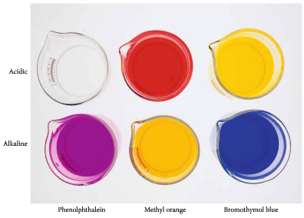

- An indicator is a weak acid and its conjugate base or a weak base and its conjugate acid.

- The weak acid has a different colour to its conjugate base.
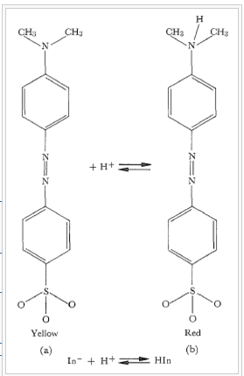

Methyl Orange

When placed into an acidic
solution, the molecule is red.

When placed into a basic
solution, the molecule is yellow

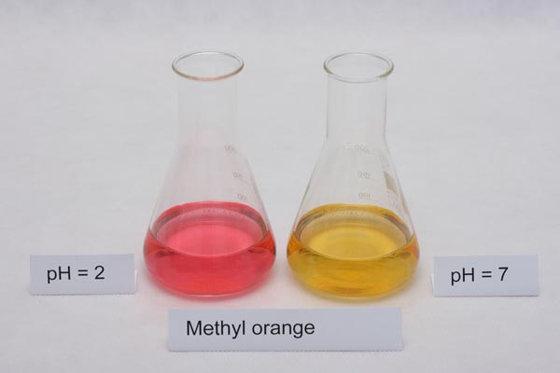

- The molecule on the left can be considered as HIn and the molecule on the right as In⁻ ion.
- When the system is at equilibrium, the following reaction is used to show the reaction.

HIn_{(aq)} ⇋ H⁺_{(aq)} + In⁻_{(aq)}

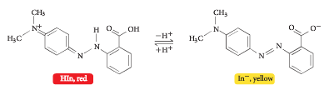

- If the indicator is added to an acidic solution, the [H⁺] increases. Le Chatelier’s Principle suggests that the equilibrium will shift to counteract the change. In this case, the equilibrium shifts to the left, making more HIn and turning the solution more red.

- If the indicator is added to a basic solution, the OH⁻ reacts with the H⁺ and the [H⁺] decreases. Le Chatelier’s Principle suggests that the equilibrium will shift to to the right, making more In⁻ ion and turning the solution more yellow.

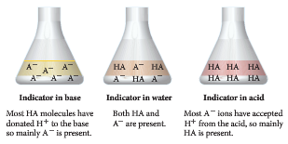
    - If methyl orange is added to a 0.01 mol L⁻¹, the pH is 2.0. [H⁺] = 1 x 10⁻² mol L⁻¹. K_{a} for methyl orange is 1.6 x 10⁻⁴. Show that equilibrium favours red.

Buffer solutions are conjugate in nature and resist changes in pH when small amounts of strong acid or base are added to the solution; buffering capacity can be explained qualitatively; Le Châtelier’s Principle can be applied to predict how buffers respond to the addition of hydrogen ions and hydroxide ions.

Buffer Solutions
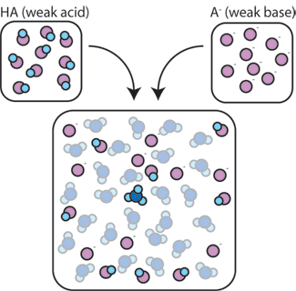
- A buffer is a solution that resists a change in its pH when small amounts of an acid or base are added.
- Consists of a mixture of a weak acid (or a weak base) and its conjugate base (or conjugate acid) - often in equimolar amounts.

HA + H₂O ⇋ A⁻ + H₃O⁺

- A buffer solution is able to react with:
- H₃O⁺_{(aq)} – introduced by addition of an acid

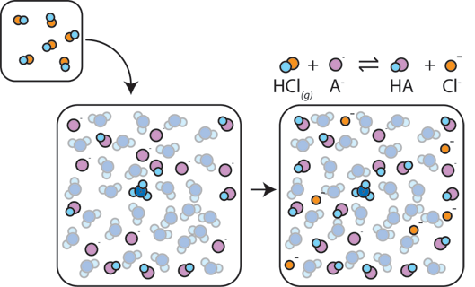

- The H⁺ gets absorbed by the A⁻ (instead of reacting with water to form H₃O⁺), so the pH doesn’t change much.
- If the salt (A⁻) is not present in sufficient amounts, there is nothing to counteract the addition of acid.

- OH⁻_{(aq)} – introduced by addition of a base

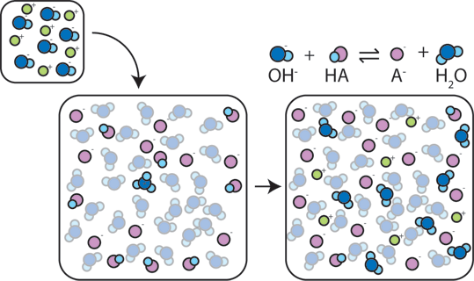

- The OH⁻ reacts with the weak acid and form water, so the pH doesn’t change much.
- If the weak (HA) is not present in sufficient amounts, there is nothing to counteract the addition of base.

- In a buffer solution prepared by acetic acid (weak acid) and sodium acetate (its conjugate base) the:

overall reaction
CH₃COOH_{(aq)} + H₂O_{(l)} + CH₃COONa(aq) ⇋CH₃COO⁻_{(aq)} + Na⁺(aq) + H₃O⁺_{(aq)}
or
CH₃COOH_{(aq)} + H₂O_{(l)} + CH₃COO⁻(aq) Na⁺(aq) ⇋ 2 CH₃COO⁻_{(aq)} + Na⁺(aq) + H₃O⁺_{(aq)}

ionic reaction
CH₃COOH_{(aq)} + H₂O_{(l)} ⇋ CH₃COO⁻_{(aq)} + H₃O⁺_{(aq)}
salt
weak acid

- In vinegar: CH₃COOH_{(aq)} + H₂O_{(l)} ⇋ CH₃COO⁻_{(aq)} + H₃O⁺_{(aq)}
99% 1%
In a buffer acid + salt CH₃COOH_{(aq)} + H₂O_{(l)} ⇋ CH₃COO⁻_{(aq)} + H₃O⁺_{(aq)}
>>1%

- If you add an acid to the buffer solution:
- The system is out of equilibrium.
- According to Le Chatelier’s Principle:
- To re-establish equilibrium, the acetate ion (CH₃COO⁻) will be removed by reacting with some of the added acid (H₃O⁺).
- Equilibrium shifts to the left.
- Since much of the added H₃O⁺ ion is removed, the overall concentration of H₃O⁺ does not alter appreciably.
- pH remains constant

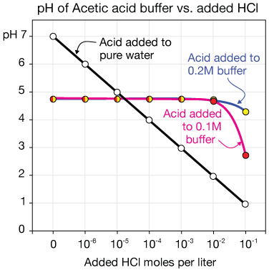

- If you add a base to the buffer solution:
- The added OH⁻ ions react with the H₃O⁺ present and the system is out of equilibrium.
- According to Le Chatelier’s Principle:
- To re-establish equilibrium, more acetic acid (CH₃COOH) reacts and the equilibrium shift to the right.
- More H₃O⁺ ion is produced, which can react with more of the added OH⁻.
- This continues until all the OH⁻ is consumed and the overall concentration of H₃O⁺ does not alter appreciably.
- pH remains constant

- In both these scenarios, much of the excess acid or base added can be consumed without changing the [H₃O⁺] – meaning no significant change in pH.

- In contrast, vinegar is not a buffer system.
- If you add H₃O⁺ to vinegar, there is only a very small proportion of CH₃COO⁻ that will react with the added acid to absorb it.
- Hence, there will be excess acid and the pH will drop.

- Adding OH⁻ will not be as much of a problem.
- Added OH⁻ use up the small amount of H₃O⁺.
- The equilibrium will shift to the right and create more H⁺ to neutralise the added OH⁻.
- This will continue until all of the vinegar is consumed.

- Explain the difference in pH when adding an acid to an ammonium ion/ammonia buffer and adding the same acid to water. GOOGLE SEARCH
NH₃(aq) + H₂O(l) ⇋ NH₄⁺(aq) + OH⁻(aq)
__________________________________________________________________________________________________________________________________________________________________________________________________________________________________________________________________________________________________________________________________________________________________________________________________________________________________________________________________________________________________________________________________________________________________________________________________________________________________________________________________________________________
- Most buffers are made by taking an acid (or base) and adding a salt that contains the conjugate base (or acid), in equimolar amounts.

- There are other ways of making a buffer.
- If a buffer was to be made with HF, the addition of NaF would create a suitable buffer.
- The same result could be achieved using a small amount of base, like NaOH.
HF + NaOH NaF + H₂O
- The OH⁻ gets used up, leaving some HF and F⁻ (hopefully in equimolar amounts).

- The table below shows what happens to the pH as volumes of 0.1 mol L⁻¹ HCl are added to 20 mL of water and 20 mL of buffer solution (0.1 M ammonium ion/0.1 M ammonia buffer solution).
Draw a rough sketch of pH v’s HCl added for both solutions.

volume of 0.1 mol L⁻¹ HCl added in mL | 20 mL pure water | 20 mL of buffer solution
0 | 7.0 | 9.2
2 | 2.0 | 9.2
4 | 1.8 | 9.1
6 | 1.6 | 9.0
8 | 1.5 | 8.9
10 | 1.5 | 8.8
12 | 1.4 | 8.4
14 | 1.4 | 8.5
16 | 1.4 | 8.3
18 | 1.3 | 8.0
20 | 1.3 | 5.0
22 | 1.3 | 2.0

- As can be seen, the buffer solution can hold the pH relatively close to the original pH for some time but when only 2.0 mL of the acid is added the pH of the water decreases over 5 units.

Buffer capacity
- Buffer solutions act as ‘shock absorbers’, keeping pH much the same when small amounts of acid or base are added.
- The extent to which a buffer solution can absorb the extra acid or base added, is called the buffer capacity.

- The buffer capacity depends on two factors:
- ________________________________________________________________________
________________________________________________________________________
________________________________________________________________________
- ________________________________________________________________________
________________________________________________________________________
________________________________________________________________________

Problem Set Answers p 41

- What is a buffer? __________________________________________________________
________________________________________________________________________
________________________________________________________________________
________________________________________________________________________
- Describe the meaning of buffering capacity.
________________________________________________________________________
________________________________________________________________________
- Explain the relationship between Le Châtelier’s principle and buffers.
________________________________________________________________________
________________________________________________________________________
________________________________________________________________________
________________________________________________________________________
- Explain why neither a weak acid nor a salt solution can act as a buffer on its own.
________________________________________________________________________
________________________________________________________________________
________________________________________________________________________
________________________________________________________________________

- Does the pH of a buffer solution change when it is diluted? Explain.
________________________________________________________________________
________________________________________________________________________
________________________________________________________________________
________________________________________________________________________
________________________________________________________________________
________________________________________________________________________
________________________________________________________________________

- Which of the following will work as a buffer system?
  - 100 mL of 0.1 M NH₄Cl with 100 mL of 100 mL 0.1 M NH₃.

  - 100 mL of 0.1 M HCl with 100 mL of 100 mL 0.2 M NH₃.

  - 100 mL of 0.1 M HCl with 100 mL of 100 mL 0.1 M NaCl.

Blood as a buffer system

Buffering in lakes GOOGLE SEARCH
- Enzymes are biological catalysts that are very sensitive to conditions. They only operate over a small range of temperature and pH values before denaturing.
- Anything that causes significant pH change in the body can lead to illness and even death.
- The pH of blood is kept between about 7.35 and 7.45 by systems of buffers.
- The three major buffers in the bloodstream include HCO₃⁻/H₂CO₃/CO₂, HPO₄²⁻/H₂PO₄⁻ and a third complex system involving proteins.

- The most common metabolic process in the body producing substances that can alter the pH of blood is respiration. Carbon dioxide is a product of respiration and is acidic.
- The buffer system that is most significant in keeping the pH constant during respiration is the carbonic acid/hydrogen carbonate system.
H₃O⁺_{(aq)} + HCO₃⁻_{(aq)} ⇋ H₂O_{(l)} + H₂CO_{3(aq)} ⇋ 2H₂O_{(l)} + CO_{2(g)}
- CO₂ gas can easily escape from the solution. As CO₂ escapes, via the lungs, the equilibrium shifts to the right, consuming excess acid (H₃O⁺).
- The actual buffer system in blood plasma is the carbonic acid/hydrogencarbonate reaction.
- This buffer consists of a weak acid, H₂CO₃ and its conjugate base, HCO₃⁻. While this buffer in its own right could regulate blood pH, the presence of the extra equilibrium reaction involving the production of gaseous CO₂ from carbonic acid makes the elimination of excess H₃O⁺ from the bloodstream even more efficient.

► Find out how buffering in lakes work and produce some notes.
___________________________________________________________________________________________________________________________________________________________________________________________________________________________________________________________________________________________________________________________________________________________________________________________________________________________________________________________________________________________________________________________________________________________________________________________________________________________________________________________________________________________________________________________________________________________________________________________________________________________________________________________________________________________________________________________________________________________________________________________________________________________________________________________________________________________________________________________________________________________________________________________________
PC 5.3 p 130-2 5.3 Review Chapter Review p 134-5 EC Set 6

PROBLEM SET p 15
- Name an acid in this reaction. NH₄⁺ (H₃O⁺ for reverse reaction)
- Use the appropriate theory to explain why the substance chosen is acting as an acid.
An acid is a proton donor. NH₄⁺ donates an H⁺ to H₂O to become H₃O⁺
A B
- HS⁻ (aq) + CO₃²⁻(aq) ⇋ S²⁻ (aq) + HCO₃⁻(aq)
B A
- HPO₄²⁻(aq) + H₂O(1) ⇋ H₂PO₄⁻(aq) + OH⁻(aq)
B A
- CH₃NH₂(aq) + CH₃COOH(aq) ⇋ CH₃NH₃⁺(aq) + CH₃COO⁻(aq)

- 2H₂0(g) + Mg(s) → Mg(OH)₂ (s) + H₂ (g) not acid/base rxn
3. Identify the conjugate acids of Cl⁻, CO₃²⁻, NH₃, ClO₄, SO₃²⁻.
HCl HCO₃⁻ NH₄⁺ HClO₄⁺ HSO₃⁻
4. Identify the conjugate bases of HF, HSO₄⁻, NH₄⁺, HPO₄²⁻, H₃O⁺.
F⁻ SO₄²⁻ NH₃ PO₄³⁻ H₂O
5. Write two equations for the hydrogen phosphate ion reacting with water as:
a. a base HPO₄²⁻_{(aq)} + H₂O_{(l)} H₂PO₄⁻_{(aq)} + OH⁻_{(aq)}
b. an acid. HPO₄²⁻_{(aq)} + H₂O_{(l)} PO₄³⁻_{(aq)} + H₃O⁺_{(aq)}
6.
a. HCO₃⁻ _{(aq)} + F⁻ _{(aq)} CO₃²⁻ _{(aq)} + HF _{(aq)}
HCO₃⁻ / CO₃²⁻ F⁻ / HF
very small as HF stronger than HCO₃⁻
b. H₃O⁺ _{(aq)} + F⁻ _{(aq)} HF _{(aq)} + H₂O _{(l)}
H₃O⁺ / H₂O F⁻ / HF
much larger degree as H₃O⁺ stronger than HF

PROBLEM SET p 20
1. Complete the following hydrolysis reactions and indicate the type of solution they form (acidic or basic).
• CO₃⁻² _{(aq)} + H₂O _{(l)} ⇋ HCO₃⁻_{(aq)} + OH⁻_{(aq)} basic
• F⁻ _{(aq)} + H₂O _{(l)} ⇋ HF_{(aq)} + OH⁻_{(aq)} basic
• HSO₄⁻ _{(aq)} + H₂O _{(l)} ⇋ H₃O⁺_{(aq)} + SO₄²⁻_{(aq)} acidic
• ClO⁻ _{(aq)} + H₂O _{(l)} ⇋ OH⁻_{(aq)} + HClO_{(aq)} basic
2. Predict the nature of each salt solution as being either acidic, basic or neutral:
• NH₄NO₃ acid • NaCl neutral
• Na₂CO₃ basic (forms HCO₃⁻) • KH₂PO₄ acidic (forms HPO₄²⁻)
• MgF₂ basic (forms HF) • K₂SO₄ neutral
- Problem Set
1. If dissolved in water, some of the substances listed here will significantly alter the concentration of hydrogen ions and hydroxide ions [H⁺ _{(aq)}, OH⁻ _{(aq)}] normally present in water. If this does occur write a net ionic equation to show how this happens. Also indicated the effect on the H⁺ _{(aq)} and OH⁻ _{(aq)} concentrations, i.e. increased or decreased or no effect. Note: (a) is a gas, the rest are solids and form aqueous solutions. Some are weak electrolytes so need a double arrow. The first has been done to show you.

- HCl HCl_{(g)} + H₂O_{(l)} → H₃O⁺_{(aq)} + Cl⁻_{(aq)} H⁺↑ OH⁻↓
- NH₄Cl NH₄⁺_{(aq)} + H₂O_{(l)} ⇋ H₃O⁺_{(aq)} + NH_{3 (aq)} H⁺↑ OH⁻↓
- LiCH₃COO CH₃COO⁻_{(aq)} + H₂O_{(l)} ⇋ OH⁻_{(aq)} + CH₃COOH _{(aq)} H⁺↓ OH⁻↑
- NaNO₃ no reaction
- K₂O O²⁻_{(aq)} + H₂O_{(l)} ⇋ 2OH⁻_{(aq)} H⁺↓ OH⁻↑
- NH₃ NH₃ _{(aq)} + H₂O _{(l)} ⇋ OH⁻ _{(aq)} + NH₄⁺ _{(aq)} H⁺↓ OH⁻↑
- Na₃PO₄ PO₄⁻³ _{(aq)} + H₂O _{(l)} ⇋ OH⁻ _{(aq)} + HPO₄⁻² _{(aq)} H⁺↓ OH⁻↑
- CH₃COOH CH₃COOH_{(aq)} + H₂O_{(l)} ⇋ H₃O⁺_{(aq)} + CH₃COO⁻_{(aq)} H⁺↑ OH⁻↓
- H₂S H₂S_{(aq)} + H₂O_{(l)} ⇋ H₃O⁺_{(aq)} + HS⁻_{(aq)} H⁺↑ OH⁻↓
- Na₂HPO₄ HPO₄²⁻_{(aq)} + H₂O_{(l)} ⇋ OH⁻_{(aq)} + H₂PO₄⁻_{(aq)} H⁺↓ OH⁻↑
- MgBr₂ no reaction
- NaHCO₃ HCO₃⁻_{(aq)} + H₂O_{(l)} ⇋ OH⁻_{(aq)} + H₂CO₃⁻_{(aq)} H⁺↓ OH⁻↑
- Ca(NO₃)₂ no reaction
- H₃PO₄ H₃PO_{4 (aq)} + H₂O_{(l)} ⇋ H₃O⁺_{(aq)} + H₂PO₄⁻_{(aq)} H⁺↑ OH⁻↓
- NaHSO₄ HSO₄⁻_{(aq)} + H₂O_{(l)} ⇋ H₃O⁺_{(aq)} + SO₄²⁻_{(aq)} H⁺↑ OH⁻↓
- K₂CO₃ CO₃²⁻_{(aq)} + H₂O_{(l)} ⇋ OH⁻_{(aq)} + HCO₃⁻_{(aq)} H⁺↓ OH⁻↑
2. A student used pieces of red and blue litmus paper to examine each of the following 1.0 mol L⁻¹ salt solutions. Describe and account for her observations, i.e. classify each solution as acidic, basic or neutral. Where the solution is not expected to be neutral, write the formula of the ion causing this.

- NaCl neutral
- KHCO₃ basic HCO₃⁻
- SrCl₂ neutral
- Mg(HSO₄)₂ acidic HSO₄⁻
- KNO₃ neutral
- NH₄Cl acidic NH₄⁺
- K₂HPO₄ basic HPO₄²⁻
- K₂S basic S²⁻
- NaCH₃COO basic CH₃COO⁻
- Mg(NO₃)₂ neutral
- Na₂CO₃ basic CO₃²⁻
- CaBr₂ neutral

PROBLEM SET p 23
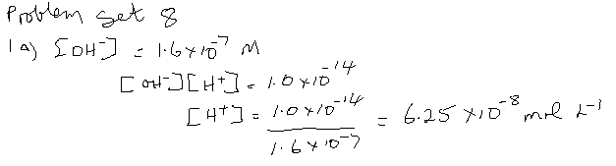
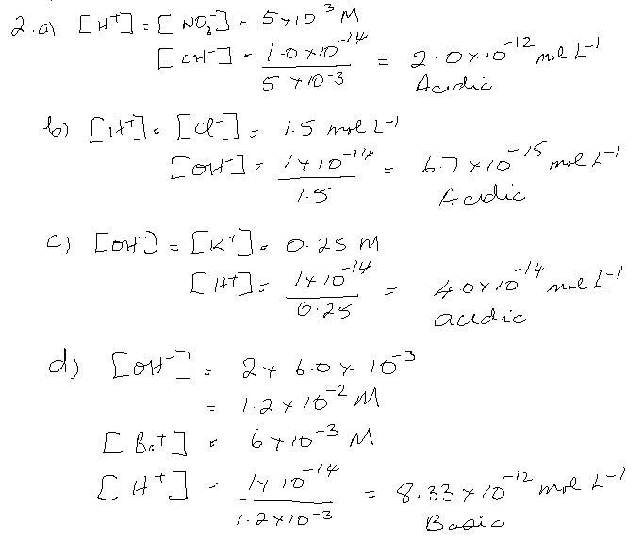
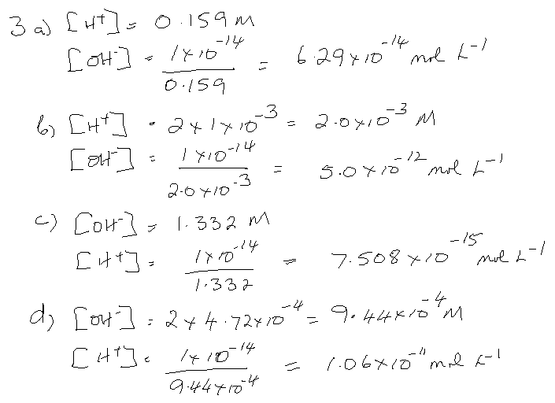

PROBLEM SET p 26
1.

a. 0.1 mol L⁻¹ HCl and 0.1 mol L⁻¹ CH₃COOH
highest [H⁺] = HCl; highest pH = CH₃COOH; greatest electrical conductivity HCl
b. 0.1 mol L⁻¹ NaOH and 0.1 mol L⁻¹ NH₃
highest [H⁺] = NH₃; highest pH = NaOH; greatest electrical conductivity NaOH
2. Give an example of each of the following:
• a concentrated solution of a strong acid. 12 M HCl
• a dilute solution of a strong base. 0.1 M NaOH
• a concentrated solution of a weak acid. 6 M CH₃COOH
3. Write equations for the ionisation or dissociation of the following:
• The strong acid HBr_{(g)}. HBr_{(g)} → H⁺_{(aq)} + Br⁻_{(aq)}
• The weak acid H₂SO₃. H₂SO_{3 (aq)} ⇋ H⁺_{(aq)} + HSO₃⁻_{(aq)}
4. Determine the final pH when the following pairs solutions are combined and the reaction is complete. Assume all solution volumes are additive.

a. 123 mL of 1.17 mol L⁻¹ NaOH _{(aq)} and 65.7 mL of 3.40 mol L⁻¹ HNO₃ _{(aq)}.
$n\left(OH^{-}\right)= n\left(NaOH\right)= cV n\left(H^{+}\right)=n\left(HNO_{3}\right)= cV$
$=1.17 x 0.123 = 3.40 x 0.0657$
$=0.1439 mol =0.2234 mol$
$$H^{+}+ {OH}^{-}→ H_{2}O$$
$$excess H^{+}=0.2234-0.1439=0.07947 mol$$
$$c\left(H^{+}\right)= \frac{n}{V}= \frac{0.07947}{(0.123+0.0657)}=0.04211 mol L^{-1}$$

$$pH= -log \left[H^{+}\right]=0.376$$

b. 375 mL of 0.152 mol L⁻¹ H₂SO₄ _{(aq)} and 443 mL of 0.130 mol L⁻¹ KOH _{(aq)}.

$n\left(H^{+}\right)=2 x n(H_{2}SO_{4})= cV n\left(KOH\right)= cV$
$=2 x 0.152 x 0.375 = 0.130 x 0.443$
$=0.1140 mol =0.05759 mol$
$$H^{+}+ {OH}^{-}→ H_{2}O$$
$$excess H^{+}=0.114-0.05759= 0.05641 mol$$
$$c\left(H^{+}\right)= \frac{n}{V}= \frac{0.05641}{(0.375+0.443)}=0.06896 mol L^{-1}$$

$$pH= -log \left[H^{+}\right]=1.16$$

5. A 4.65 g sample of pure NaOH _{(s)} is added to 626 mL of 0.135 mol L⁻¹ HCl _{(aq)}. Assume the final volume of the mixture is unchanged and determine the pH of the mixture when the reaction is complete.

$n\left(OH^{-}\right)= n\left(NaOH\right)= \frac{m}{M} n\left(H^{+}\right)=n\left(HCl\right)= cV$
$=\frac{4.65}{39.998} = 0.135 x 0.626$
$=0.1163 mol =0.08451 mol$
$$H^{+}+ {OH}^{-}→ H_{2}O$$
$$excess {OH}^{-}=0.1163 - 0.08451=0.03179 mol$$
$$c\left({OH}^{-}\right)= \frac{n}{V}= \frac{0.03179}{0.626}=0.05078 mol L^{-1}$$
$pOH= -log \left[{OH}^{-}\right]=1.294$ $c\left(H^{+}\right)= \frac{{10}^{-14}}{0.05078}=1.969 x {10}^{-13}$
$pH= 14-pOH=14-1.294=12.7$ $pH= -log \left[H^{+}\right]=12.7$

Problem Set p 34

- What is a buffer? A solution that resists rapid changes in pH when an acid or base is added. A buffer is usually made by mixing together a weak acid or base and the salt of that acid or base. Thus it contains a weak Brønsted-Lowry acid and its conjugate base or a weak Brønsted-Lowry base and its conjugate acid.
- Describe the meaning of buffering capacity.
Buffering capacity is the amount of protons or hydroxide ions it can absorb without a significant change in the pH
- Explain the relationship between Le Châtelier’s principle and buffers.
A weak acid and weak base are both present, in equilibrium, in a buffer solution. Thus any small amounts of either an acid (H⁺) or a base (OH⁻) added to the buffer will be neutralised and the pH will change very little, if at all. The equilibrium moves to minimise the change as described in Le Chatelier’s principle.

- Explain why neither a weak acid nor a salt solution can act as a buffer on its own.
A weak acid would not have enough anions (negative ions) to react with the added hydrogen ions. The salt solution would not have enough undissociated acid to react with the added hydroxide ions.

- Does the pH of a buffer solution change when it is diluted? Explain.
No. The buffering capacity depends on the ratio of the concentrations of the acid (HA) and its conjugate base (A⁻), not on the actual values.
It is most effective when the concentrations are equal to each other (their ratio, [HA] : [A⁻] = 1). Diluting the solution does not change this ratio.
$pH=pK_{a}+log(\frac{\left[base\right]}{[acid]})$ base = A⁻, acid = HA buffer – [A⁻] = [HA]
$$when \frac{[A^{-}]}{[HA]}=1, log 1=0 pH=pK_{a} (pK_{a}= -inv log K_{a})$$
Dilution – does not change the ratio of $\frac{[A^{-}]}{[HA]}$ . So does not change K_{a}. No effect on pH.
However, it will have a lower buffering capacity – less concentrated.
- Which of the following will work as a buffer system?
  - 100 mL of 0.1 M NH₄Cl with 100 mL of 100 mL 0.1 M NH₃.
WB and CA (salt), equimolar ✔
  - 100 mL of 0.1 M HCl with 100 mL of 100 mL 0.2 M NH₃.
HCl + NH₃ NH₄Cl HCl used up, excess NH₃, NH₄Cl produced
WB and CA (salt), equimolar ✔
  - 100 mL of 0.1 M HCl with 100 mL of 100 mL 0.1 M NaCl.
SA and CB (salt) ✗

